IT 511: Object Oriented Application Development
Module Five: Control Structures: Loops and Arrays
ZyBooks: Programming in Java: Early Objects
Chapters 7 & 8
4/18/22

Learning Objectives

- Identify how iteration with loops is used to address specific problems
- Develop methods establishing a loop structure for controlled iteration
- Construct collection and item classes for a functioning collection manager program

Textbook Sections

Chapter 7: Loops
- 7.1 Loops
- 7.2 While Loops
- 7.3 More While Examples
- 7.4 Do-While Loops
- 7.5 Counting
- 7.6 For Loops
- 7.7 Nested Loops
- 7.8 Incremental Programming
- 7.9 Break and Continue
- 7.10 Enumerations (Optional)
- 7.11 Java Example: Salary Calculation With Loops
- 7.12 Java Example: Domain Name Valuation With Loops (Optional)
Chapter 8: Arrays
- 8.1 Array concept
- 8.2 Arrays
- 8.3 Array iteration drill
- 8.4 Iterating through arrays
- 8.5 ArrayList

Module Overview


Image 5.1
(Image Source: Meath Chronicle)
Loops can be a thrill, especially on a rollercoaster.
Some people enjoy rollercoasters; others find them terrifying. For many of us, it is a little of each: We are willing to abide the fright in order to experience the thrill. No matter how we may feel about this experience, there is no turning back. Once the safety bar is locked in, we are captives while the ride cycles through its looping route; there is no exit while we are on board. The control structures known as “loops” in object-oriented programming generally are not as thrilling or scary as rollercoasters are, but they function in a similar fashion. For instance, the control structures known as “while loops” allow the program to cycle through data while a certain condition is true. A loop allows the programmer to execute a statement or group of statements multiple times, working or iterating through the data for as long as is needed, depending on the parameters of the loop. The ride can be long or short, and its purpose and function are in the programmer’s control.
In object-oriented programming, iteration is the repetition of a process or sequence in the code. Often, iteration is coded through a control structure known as a loop.
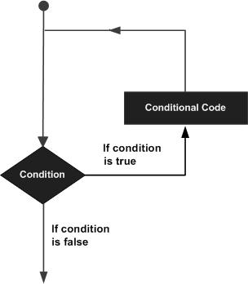
Image 5.2
(Image source: Tutorialspoint)
Conditional statements and Boolean “true/false” logic are used to construct loops in object-oriented programming.
In Module Five, you will explore when and how to use loops. The diagram above provides a quick look at how a loop can structure conditional statements. In this case, the code in the loop is applied to the data that scans as “true” in a conditional statement. As you will note as you work through the zyBooks resource, loops typically are a “while” conditional structure. “For” loops provide an alternative coding structure for counting in loops, and both “for” and “while” loops can be used for more complex functions that entail the use of outer and inner loops. Break statements are like an emergency exit to get out of the loop if you need to exit it prematurely. This selection from the zyBooks also contains good advice about coding incrementally; as structures become more complex, there is a greater need to build component by component, testing along the way.
In this module, you will have the opportunity to put knowledge into practice with the fourth stepping stone lab and the first milestone. Stepping Stone Lab Four builds on the last stepping stone by again using conditionals but this time in a loop structure. In this module, you will also take the next step toward a successful final project by completing the first final project milestone. Here, you will create a complete class, providing it the basic attributes with the appropriate data types.

